Xero registration

Made on 27.09.2018.

To use the API of Xero you will need to generate API credentials.

1. Go to the page <https://www.xero.com/signup/api/>, enter information about you and click ‘Sign Up’.

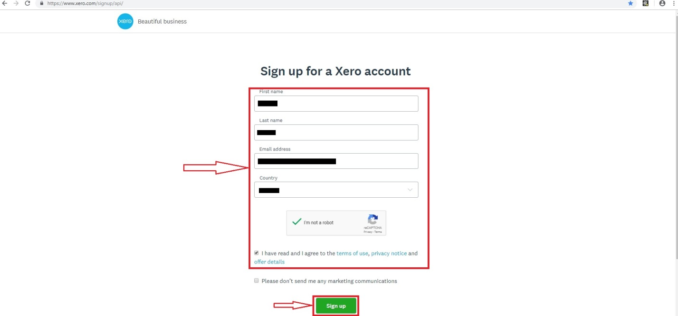

1. You need to verify your e-mail.

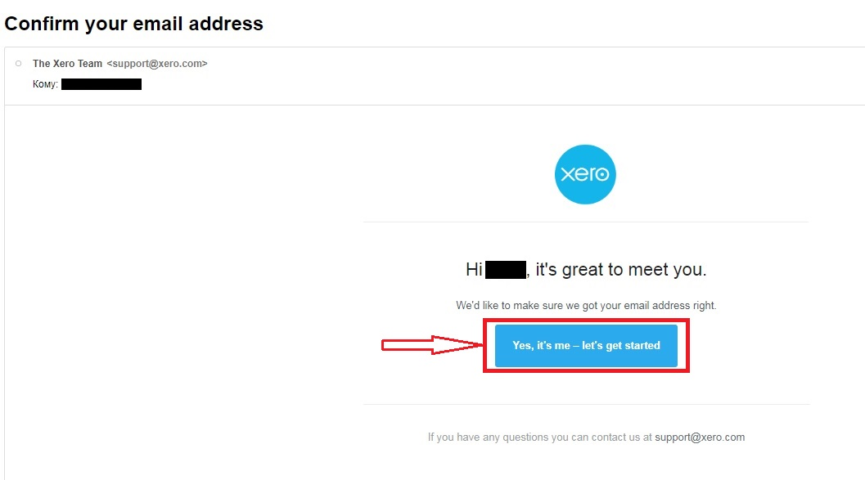

1. You have to enter your new password for service and phone and click ‘Activate Your Account’.

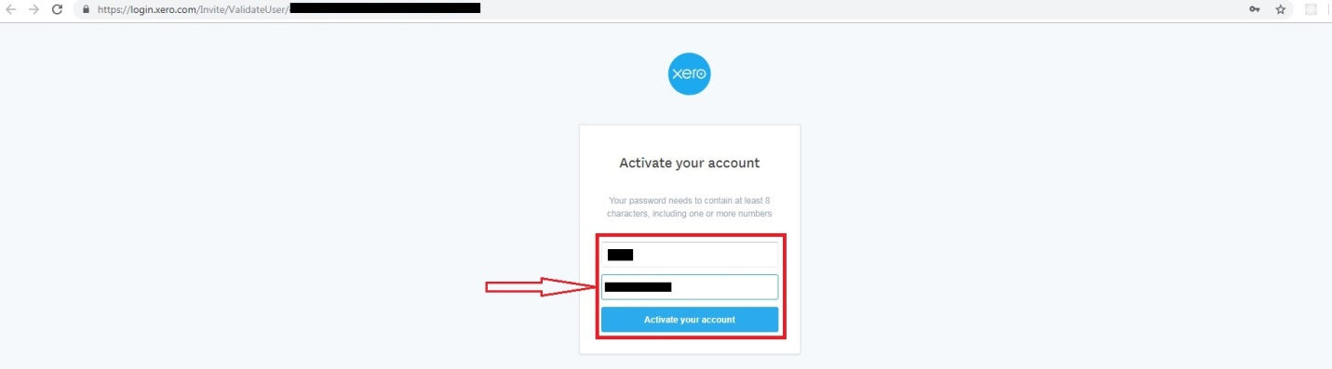

1. You have to go to the Xero developers page <https://developer.xero.com/myapps> and click ‘New App’.

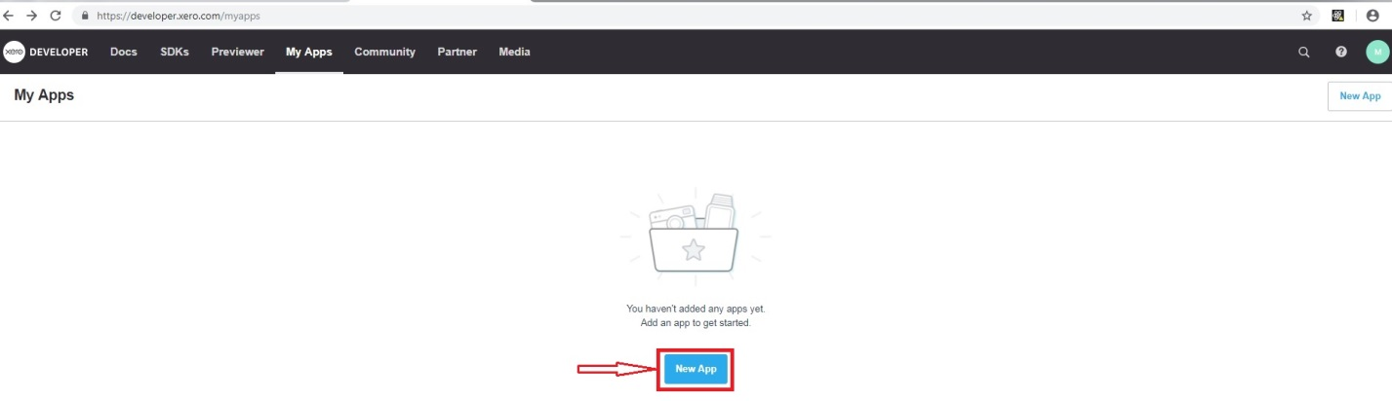

1. You have to choose ‘Public App’, enter information about your App and click ‘Create App’.

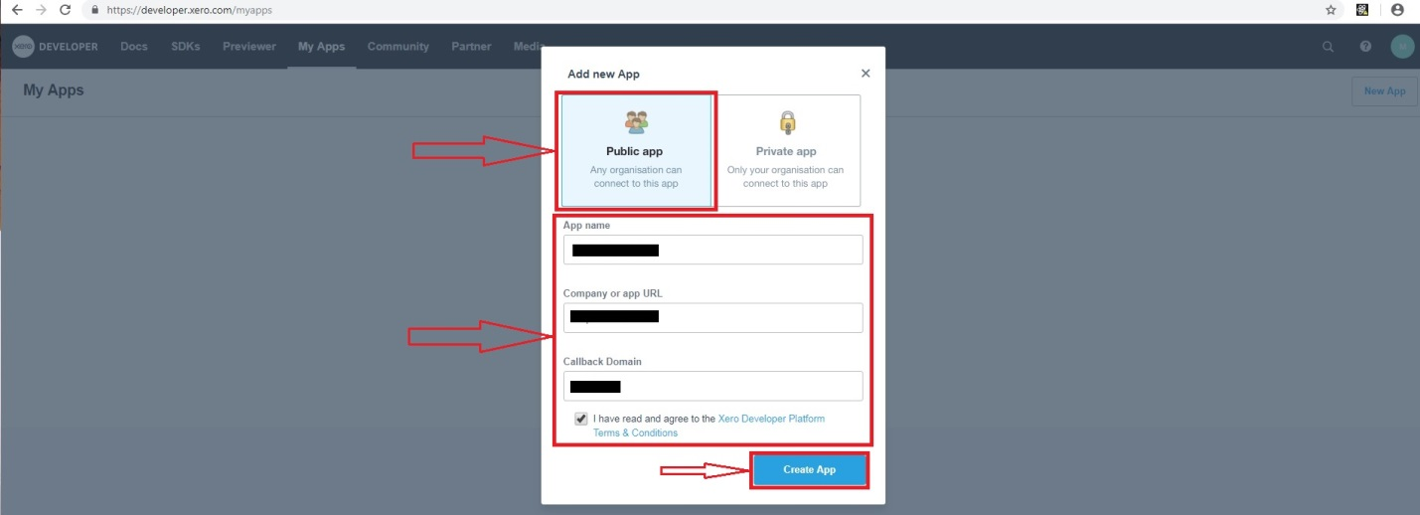

1. Your API credentials.

